Task: Use the model to explain how the chemical reactions of photosynthesis and respiration support life on earth

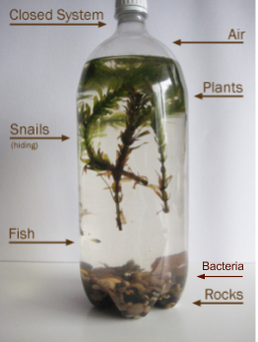 | Note: The liquid is freshwater and the snails and fish both feed on the plants in the bottle.

INDIVIDUAL EXPLANATION: Use the picture above and explain the following in your notebook. Answer each question as a paragraph (3-5 sentences). Each paragraph should start with a claim and provide evidence from your notes and/or the model above.

- How do the chemical reactions of photosynthesis and respiration work together to support human survival on Earth?

- Predict what would happen to the ability of organisms in the ecobottle to perform photosynthesis and respiration if there were no snails or fish.

