7.1.3 - Student Task Card
INFOGRAPHIC: PHASE CHANGES
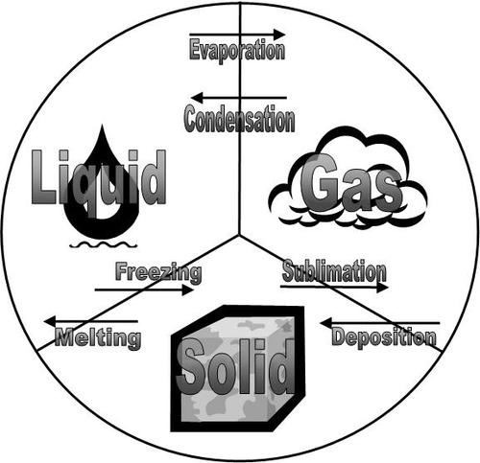
An INFOGRAPHIC is a visual image such as a chart or diagram used to represent information or data. Some say that "a good infographic is worth a thousand words."

This infographic includes information about PHASE CHANGES.

INSTRUCTIONS:
1) Color the attached infographic first, then cut it out, and glue it into your notebook, adding the title INFOGRAPHIC: PHASE CHANGES

2) On the same page in your notebook, build and complete the following table (fill the entire page) to summarize and organize the vocabulary and information explained through the infographic. Include the example provided.

3) VOCABULARY - Highlight or underline each time
you use a phase change vocabulary word.

Phase Change | Definition | Example | Picture
1) Deposition | Deposition is a process where a gas changes phase and turns directly into a solid without passing through the liquid phase. | Snow - water vapor in clouds changes directly to ice | 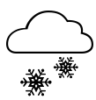
2) |  | Dry ice - as it breaks down, it turns directly into carbon dioxide gas rather than a liquid
3) Condensation

4) |  |  | 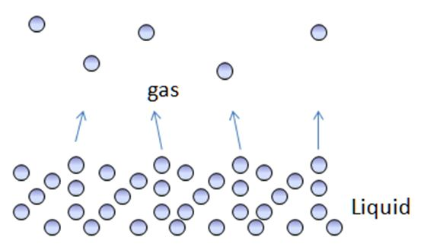
5) | Melting is a process where a solid changes phase and changes to a liquid
6)

