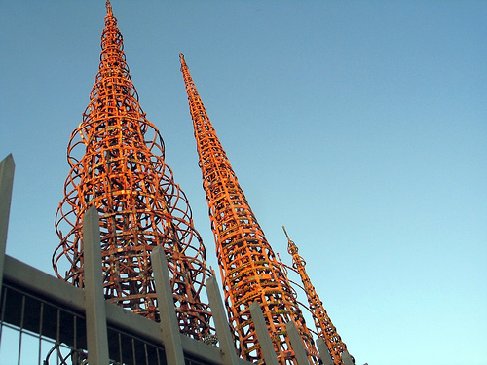
The Tower

The word structure brings to mind different things to different people, especially among the various cultures and societies of the world. A Native American in parts of Alaska might think of a temporary shelter made of blocks of snow. On some Pacific islands a grass dwelling built high off the ground on wooden stilts is a common structure. We who live in an industrial society might think of a skyscraper, a suspension bridge, or a domed stadium. All of these are structures, and the urge to build structures seems to be a part of all human cultures.

All structures great or small, of steel, stone, or even paper have one thing in common - they are designed to carry loads. Loads are the various forces that push or pull on a structure, and a well- designed structure will withstand these forces without collapsing. A major force that puts loads on structures is gravity (the pull on the structure). Gravity is the force responsible for the weight of water held back by a dam, the weight of people standing on a bridge, and the weight of the roof held up by the walls of your house.

In order to stay up, buildings and other structures must be able to support loads (push up against gravity). Gravity (the force directed towards the Earth) pulls down on the tower. The structural integrity of the tower exerts as much force up in the opposite direction of gravity.

As long as the tower pushes up equally against gravity the tower is secure. The forces are balanced. Once that tower starts to lean or buckle gravity swiftly overcomes the structure and collapse is imminent. The consequences are not grave in this situation but if this was a structure holding a walkway or a home....

