TASK PROBLEM:
- Develop a model that shows how a pure substance, gallium, undergoes a phase change.
- Construct an explanation for how the increase in thermal energy caused the phase change.

Below is a picture of a pure metal disk made of the element, gallium. The disk was placed into a beaker where the water has been heated to a temperature of 40°C.

You will also watch a video to see the phase change take place.  In addition, here is some information to help with your model and explanation:  - Room temperature: 25°C  - Melting point of gallium: 30°C  - Boiling Point of Water 100°C | 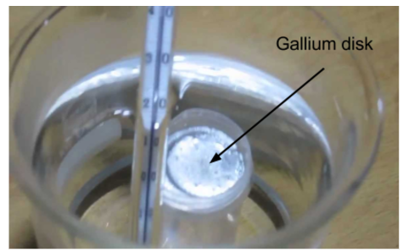

Your model will:
- Show gallium as individual particles
- Identify gallium’s state of matter BEFORE and AFTER the phase change
- Show water and glass beaker as part of the system
- Demonstrate spacing between the particles and particle motion of gallium in two different states
- Show energy transfer between two objects

Your explanation will:
- Explain how the transfer of energy between two objects caused a phase change
- Explain differences between water and gallium caused by an increase in thermal energy

